L1F21BSCS0097
Ahmad Sachyar
Assignment 1
Submitted to:
Sir Ali Raza
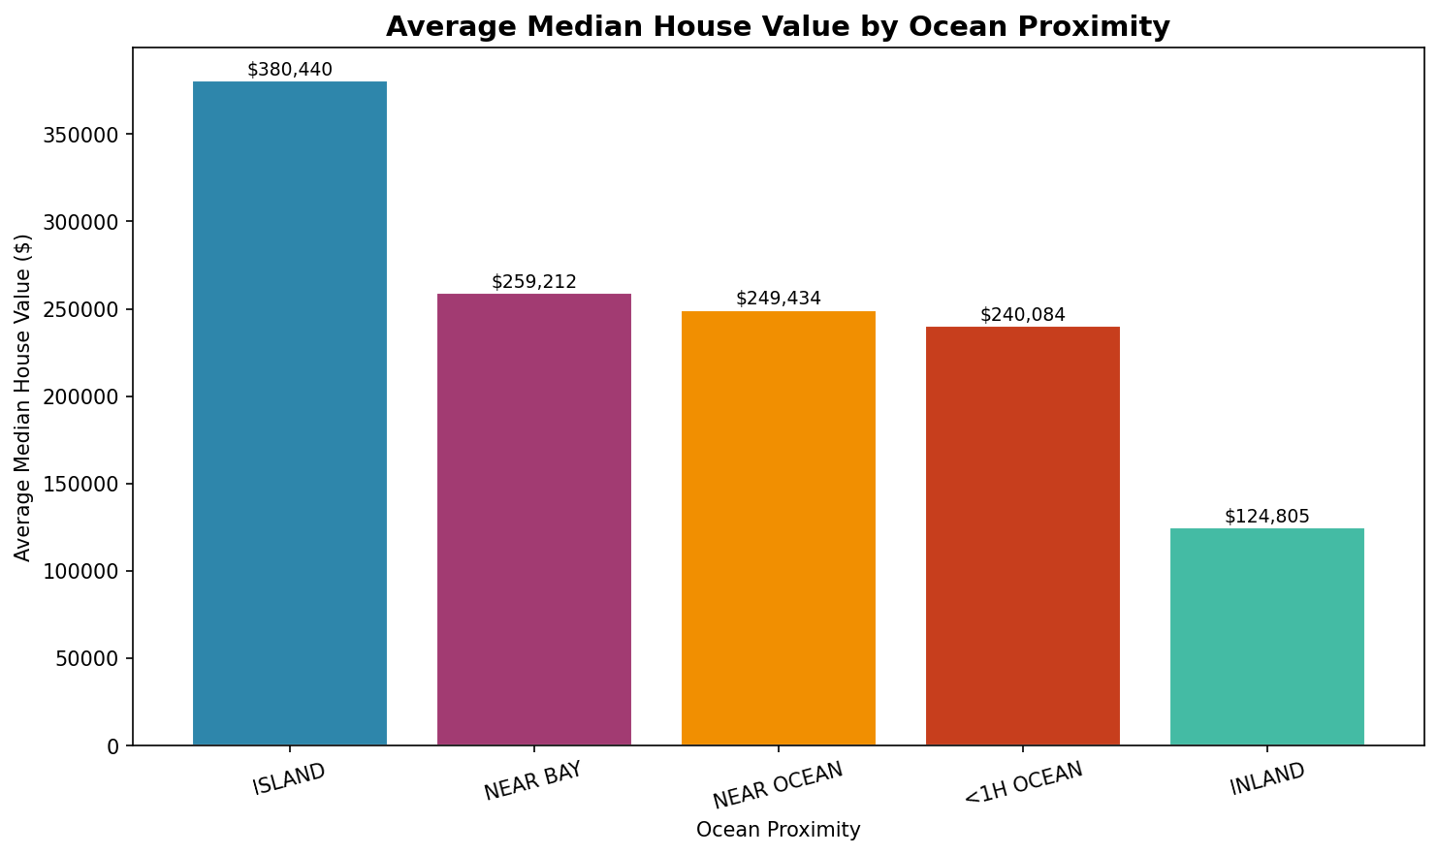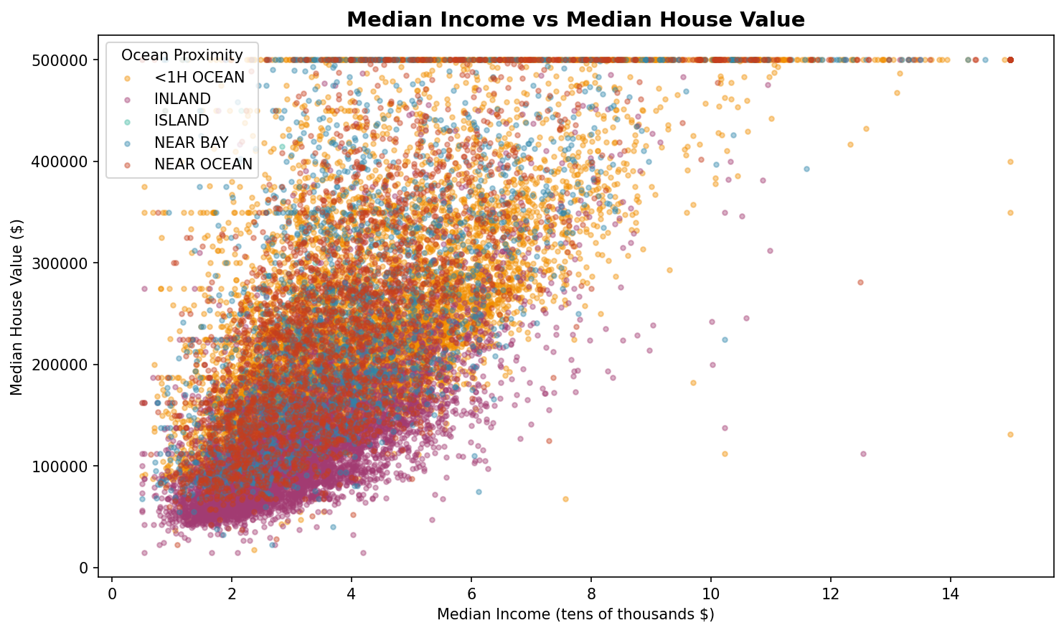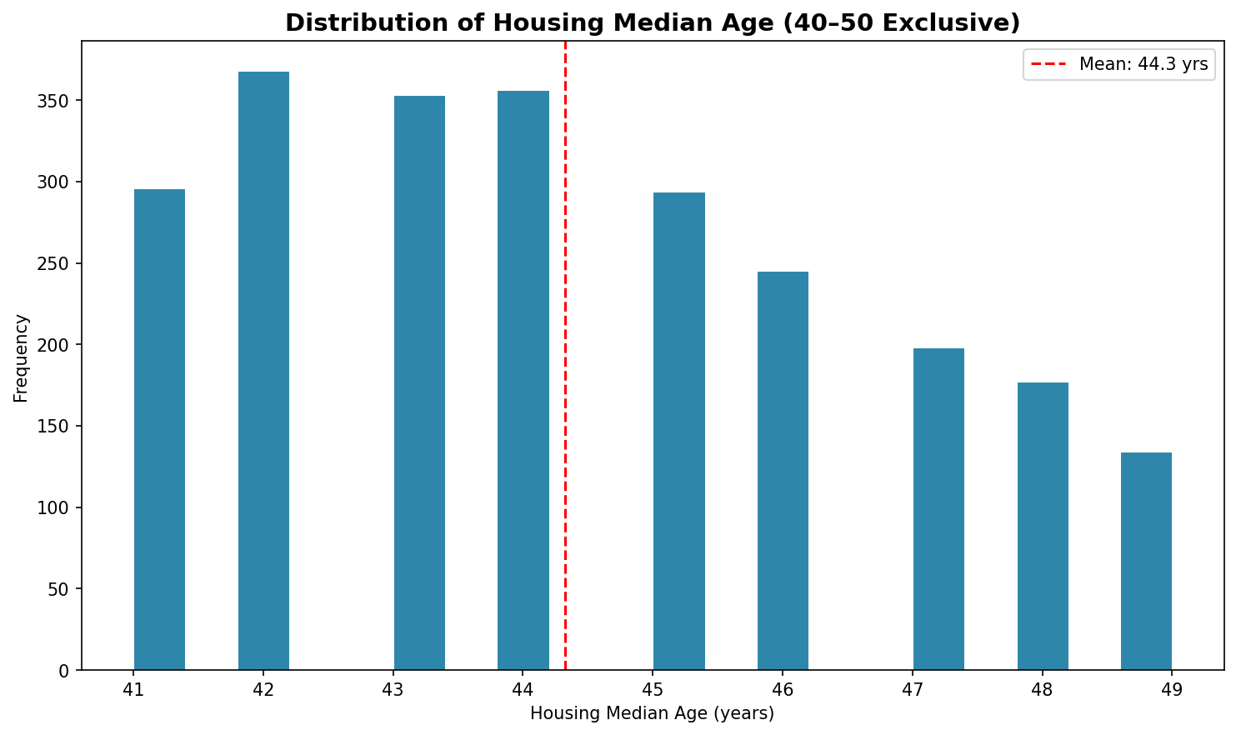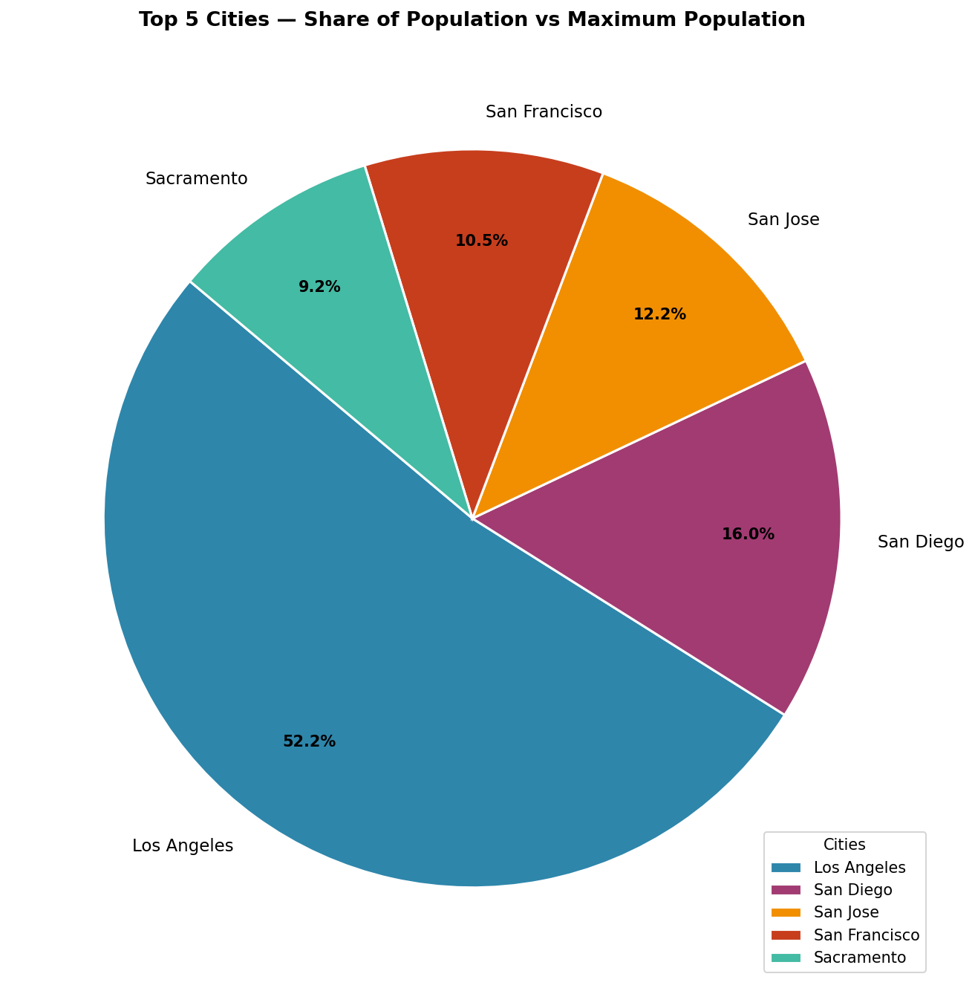

import pandas as pd
import numpy as np
import matplotlib.pyplot as plt
print("L1F21BSCS0097 Ahmad Sachyar")
zipcodevalues = ["94705.0", "94611.0", "94618.0", "95935.0", "95972.0", "95962.0"]
housing_data = pd.read_csv("housing.csv")
housing_addresses = pd.read_csv("housing_addresses.csv")
print("Task 1")
print("housing_data")
print(housing_data.head(10).to_string(index=True))
print()
print("housing_addresses")
print(housing_addresses.head(10).to_string(index=True))
print()
print("L1F21BSCS0097 Ahmad Sachyar")
print("Task 2")
print("housing_addresses")
print()
housing_addresses.rename(columns={"postal_code": "zip_code"}, inplace=True)
print(housing_addresses.head(1).to_string(index=True))
housing_addresses.rename(columns={"zip_code" : "postal_code"}, inplace=True)
print()
print("L1F21BSCS0097 Ahmad Sachyar")
print("Task 3")
print("housing_data")
print()
housing_data["zip_code"] = None
print(housing_data.head(1).to_string(index=True))
print()
print("L1F21BSCS0097 Ahmad Sachyar")
print("Task 4")
print("housing_data")
print()
housing_data["zip_code"] = np.random.choice(zipcodevalues, size=len(housing_data))
print(housing_data.head(5).to_string(index=True))
print("Task 5")
print("L1F21BSCS0097 Ahmad Sachyar")
print("Data Frame L1F21BSCS0097")
print()
housing_addresses[['lat_key', 'lon_key']] = (
housing_addresses['latitude_longitude']
.str.split(',', expand=True)
.astype(float)
)
housing_data['lat_key'] = housing_data['latitude']
housing_data['lon_key'] = housing_data['longitude']
housing_addresses['lat_key'] = housing_addresses['lat_key']
housing_addresses['lon_key'] = housing_addresses['lon_key']
L1F21BSCS0097 = pd.merge(
housing_data,
housing_addresses,
on=['lat_key', 'lon_key'],
how='left'
)
L1F21BSCS0097.drop(columns=['lat_key', 'lon_key'], inplace=True)
print(L1F21BSCS0097.head(10).to_string(index=True))
print()
print("Task 5")
print()
print("Bar Chart")
avg_value = L1F21BSCS0097.groupby('ocean_proximity')['median_house_value'].mean().sort_values(ascending=False)
plt.figure(figsize=(10, 6))
bars = plt.bar(avg_value.index, avg_value.values, color=['#2E86AB','#A23B72','#F18F01','#C73E1D','#44BBA4'], edgecolor='white')
plt.title('Average Median House Value by Ocean Proximity', fontsize=14, fontweight='bold')
plt.xlabel('Ocean Proximity')
plt.ylabel('Average Median House Value ($)')
plt.xticks(rotation=15)
for bar, val in zip(bars, avg_value.values):
plt.text(bar.get_x() + bar.get_width()/2, bar.get_height() + 1000,
f'${val:,.0f}', ha='center', va='bottom', fontsize=9)
plt.tight_layout()
plt.savefig('barchart.png', dpi=150, bbox_inches='tight')
plt.show()
print()
print("Scatter Plot")
colors_map = {
'NEAR BAY': '#2E86AB',
'INLAND': '#A23B72',
'<1H OCEAN': '#F18F01',
'NEAR OCEAN': '#C73E1D',
'ISLAND': '#44BBA4'
}
plt.figure(figsize=(10, 6))
for proximity, group in L1F21BSCS0097.groupby('ocean_proximity'):
plt.scatter(group['median_income'],
group['median_house_value'],
label=proximity,
color=colors_map.get(proximity, 'gray'),
alpha=0.4,
s=10)

plt.title('Median Income vs Median House Value', fontsize=14, fontweight='bold')
plt.xlabel('Median Income (tens of thousands $)')
plt.ylabel('Median House Value ($)')
plt.legend(title='Ocean Proximity', loc='upper left')
plt.tight_layout()
plt.savefig('scatterplot.png', dpi=150, bbox_inches='tight')
plt.show()
print()
print("Histogram")
filtered_age = L1F21BSCS0097[
(L1F21BSCS0097['housing_median_age'] > 40) &
(L1F21BSCS0097['housing_median_age'] < 50)
]['housing_median_age']

plt.figure(figsize=(10, 6))
plt.hist(filtered_age, bins=20, color='#2E86AB', edgecolor='white', linewidth=0.5)
plt.title('Distribution of Housing Median Age (40–50 Exclusive)', fontsize=14, fontweight='bold')
plt.xlabel('Housing Median Age (years)')
plt.ylabel('Frequency')
plt.axvline(filtered_age.mean(), color='red', linestyle='--', linewidth=1.5,
label=f'Mean: {filtered_age.mean():.1f} yrs')
plt.legend()
plt.tight_layout()
plt.savefig('histogram.png', dpi=150, bbox_inches='tight')
plt.show()
print()
print("Pie Chart")
city_population = L1F21BSCS0097.groupby('locality-political')['population'].sum()
top5_cities = city_population.sort_values(ascending=False).head(5)
max_population = city_population.max()

top5_share = (top5_cities / max_population) * 100

plt.figure(figsize=(9, 9))
wedges, texts, autotexts = plt.pie(
top5_share.values,
labels=top5_share.index,
autopct='%1.1f%%',
colors=['#2E86AB','#A23B72','#F18F01','#C73E1D','#44BBA4'],
startangle=140,
pctdistance=0.75,
wedgeprops=dict(edgecolor='white', linewidth=1.5)
)
for text in texts:
text.set_fontsize(11)
for autotext in autotexts:
autotext.set_fontsize(10)
autotext.set_fontweight('bold')

plt.title('Top 5 Cities — Share of Population vs Maximum Population',
fontsize=13, fontweight='bold', pad=20)
plt.legend(wedges, top5_share.index, title='Cities', loc='lower right', fontsize=10)
plt.tight_layout()
plt.savefig('piechart.png', dpi=150, bbox_inches='tight')
plt.show()
print("L1F21BSCS0097 Ahmad Sachyar")

